Dongsha Atoll Conservation Categorization
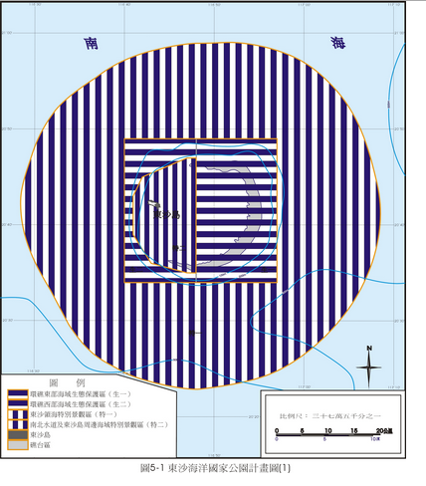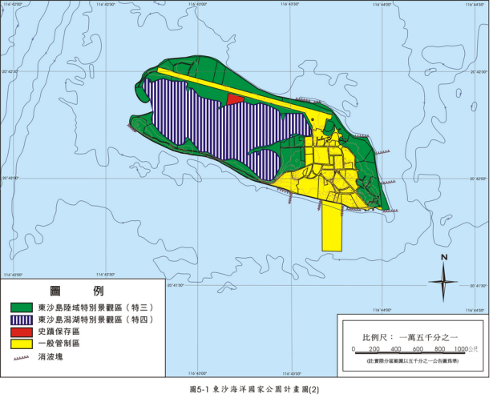
Horizontal bars indicate Ecological Reserve. Entering and Collection in this area requires 14 working days of processing. Other areas, including Dongsha Island, requires 5 working days.
Red: Historical Site, Green: Scenic Area, Yellow: General Restricted Area

See next page for an application form

