Duration:
6 /11-6/18

Project and purpose:
東沙軟珊瑚多樣性調查 (Soft Coral biodiversity investigation in Dongsha Atoll)

People:
Yehuda Benayahu, Catherine McFadden

Works in Dongsha:
Soft coral collections.

Sites:
6/12
20° 44'.422 N
116°54'865 E 20M

6/13 northern Channel near Dongsha Island,
20° 43'.448 N
116° 42'.520 E

6/14
20° 40'.509 N
116° 55'.319 E

6/15
20° 41'.994 N
116° 55'.370 E

6/16 southeast
20° 35'.859 N
116° 51'.380 E

Phtos: as attached 0446, 0485.jpg

Suggestions:
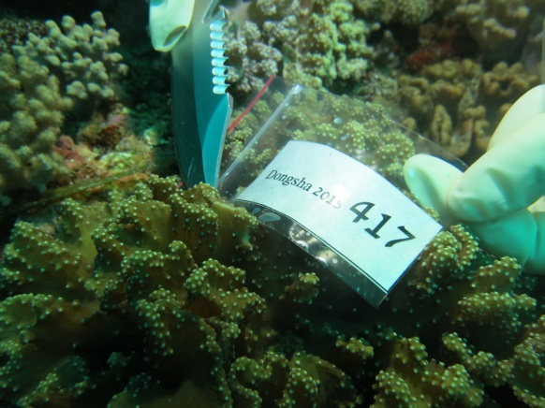 sample collection
